EXPERIMENT NO. 4
Library Book Reservation System for SIMATS Library using Zoho Creator (SaaS)

Aim
To develop a cloud-based Library Book Reservation System for SIMATS Library using Zoho Creator to manage book reservations and returns.

Objective
• Create a SaaS application.
• Store book and student details.
• Maintain reservation status.
• Generate reports.

Software Requirements
Zoho Creator, Deluge Script, Google Chrome, Internet Connection.

Theory
Zoho Creator is a cloud-based low-code platform. This application stores library reservation data including student information, book details, status, reservation date and return date. Reports help librarians monitor all transactions.

Fields Used
Student Name, Register Number, Book Title, Author, Publication, Year, Edition, Number of Copies, Rack Number, Status (Taken/Returned), Reservation Date, Return Date.

Procedure
1. Create the application.
2. Design the reservation form.
3. Add required fields.
4. Create a Deluge workflow for return alert.
5. Enter sample records.
6. Create a report.
7. Verify individual records.

Algorithm
Start → Enter Details → Select Status → Submit → Save Record → Display Alert → Generate Report → Stop.

Observation
The application accepted all records successfully. Reservation details were stored in the cloud. The return alert worked correctly. Reports displayed all reservations and individual records.

Result
The Library Book Reservation System was successfully implemented using Zoho Creator and demonstrated SaaS functionality.

Conclusion
The experiment proved that Zoho Creator can be used to develop a cloud-based library management application efficiently.

Input
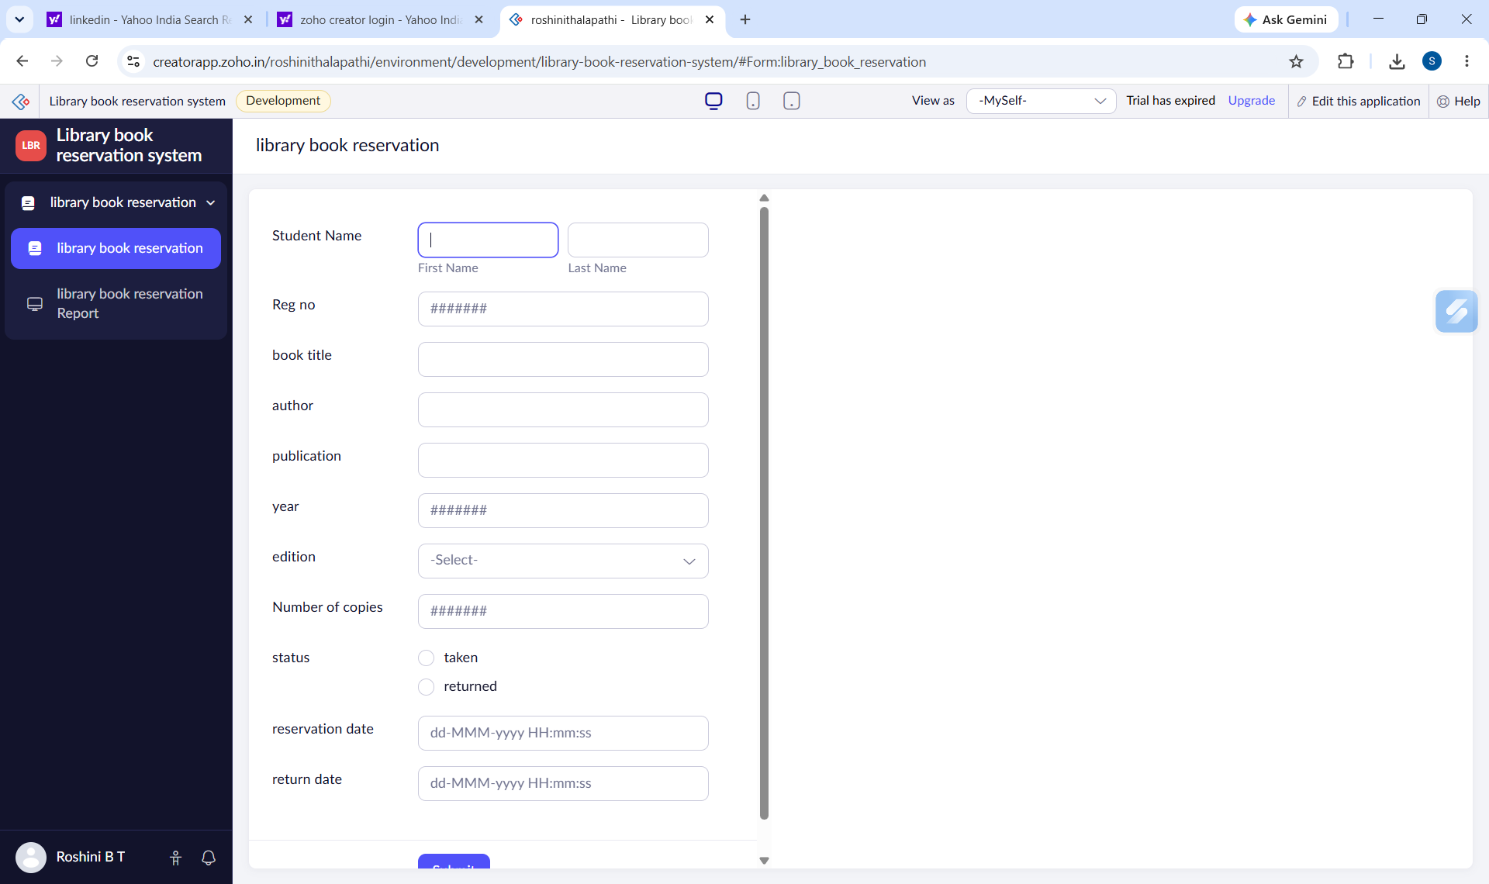
Figure 1: Library Book Reservation Form

Output

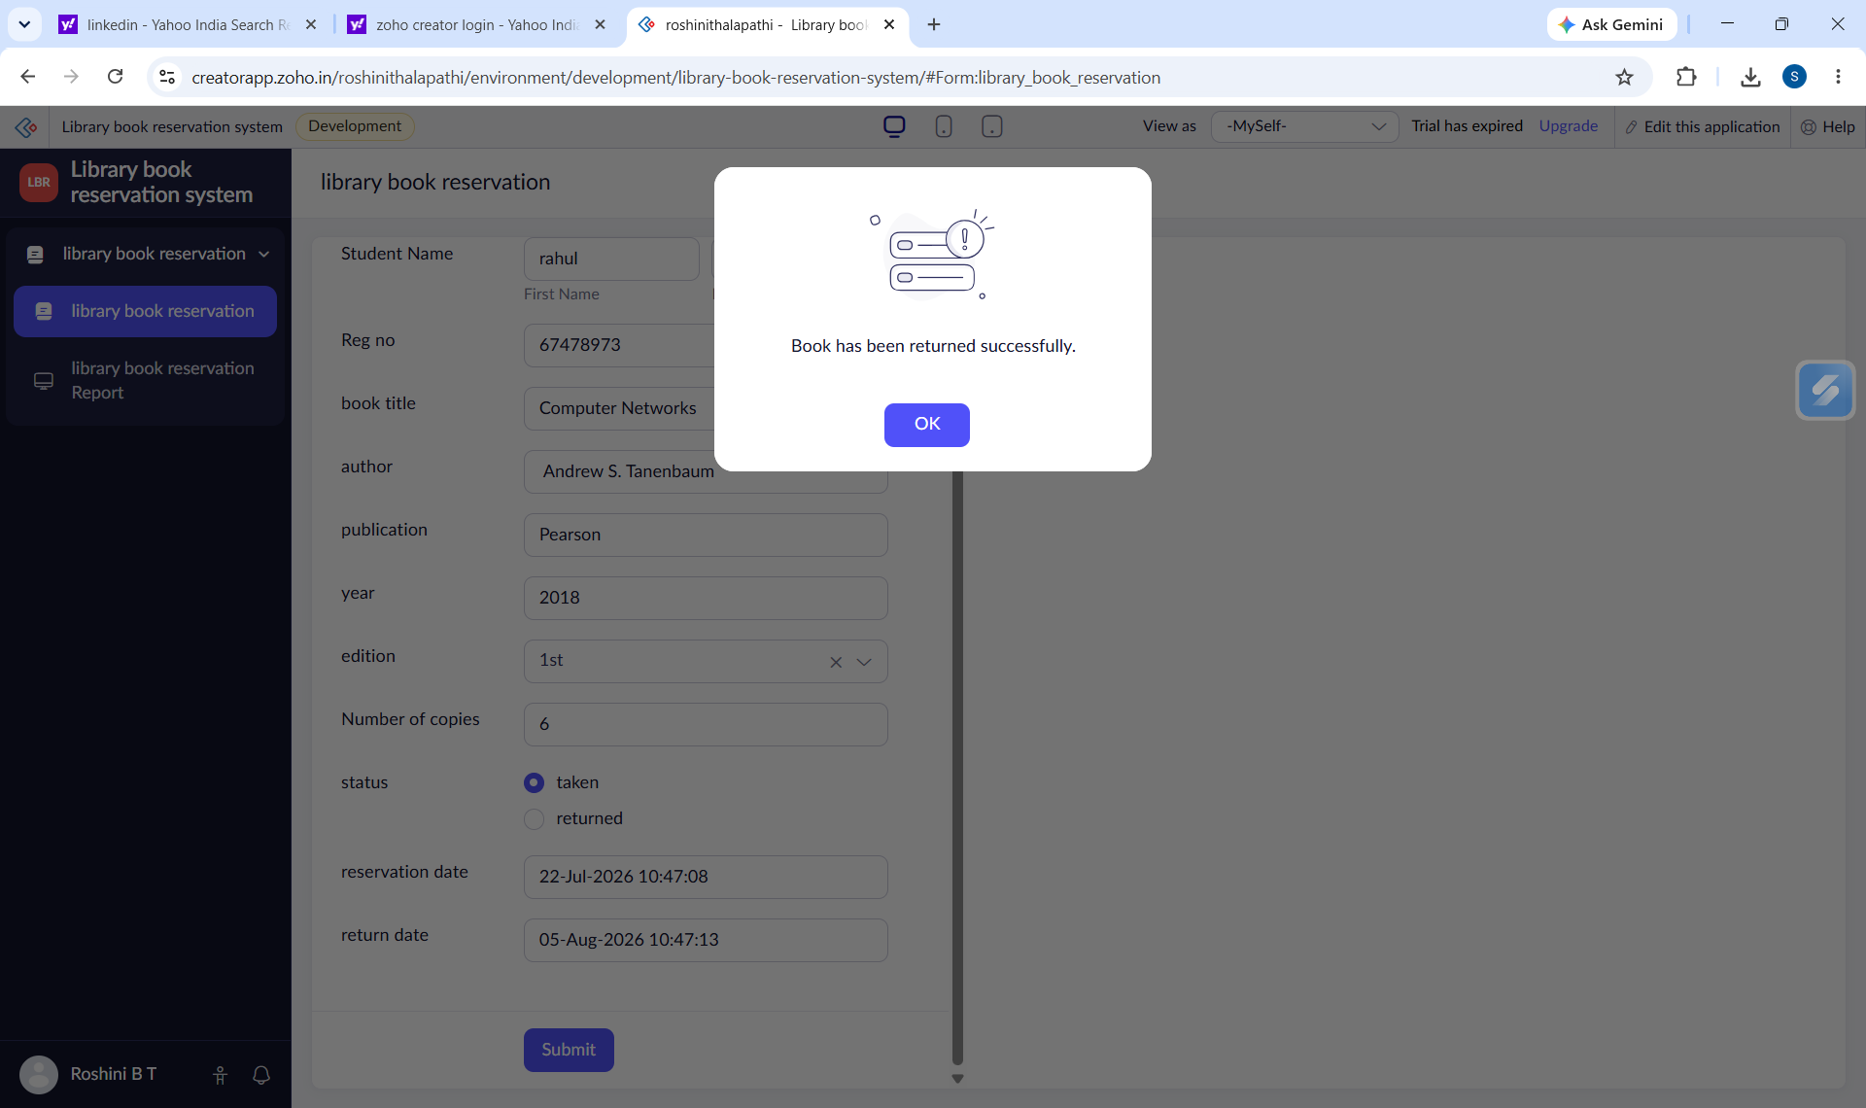
Figure 2: Return Confirmation Alert
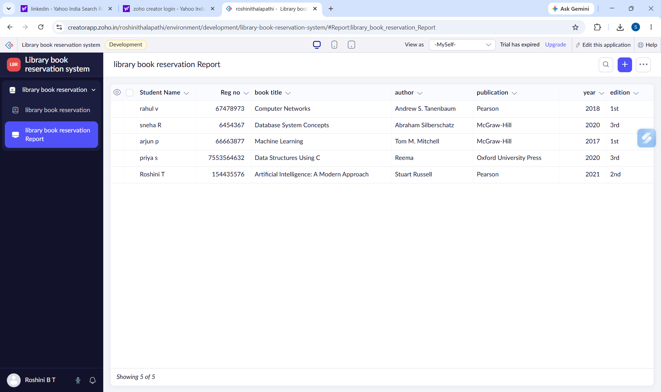
Figure 3: Reservation Report
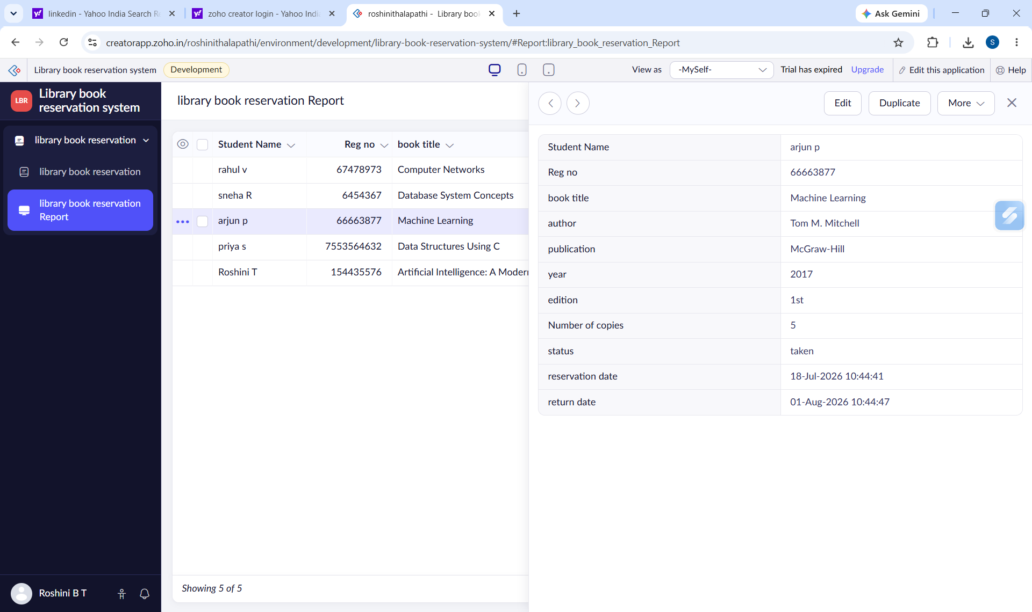
Figure 4: Individual Record View

